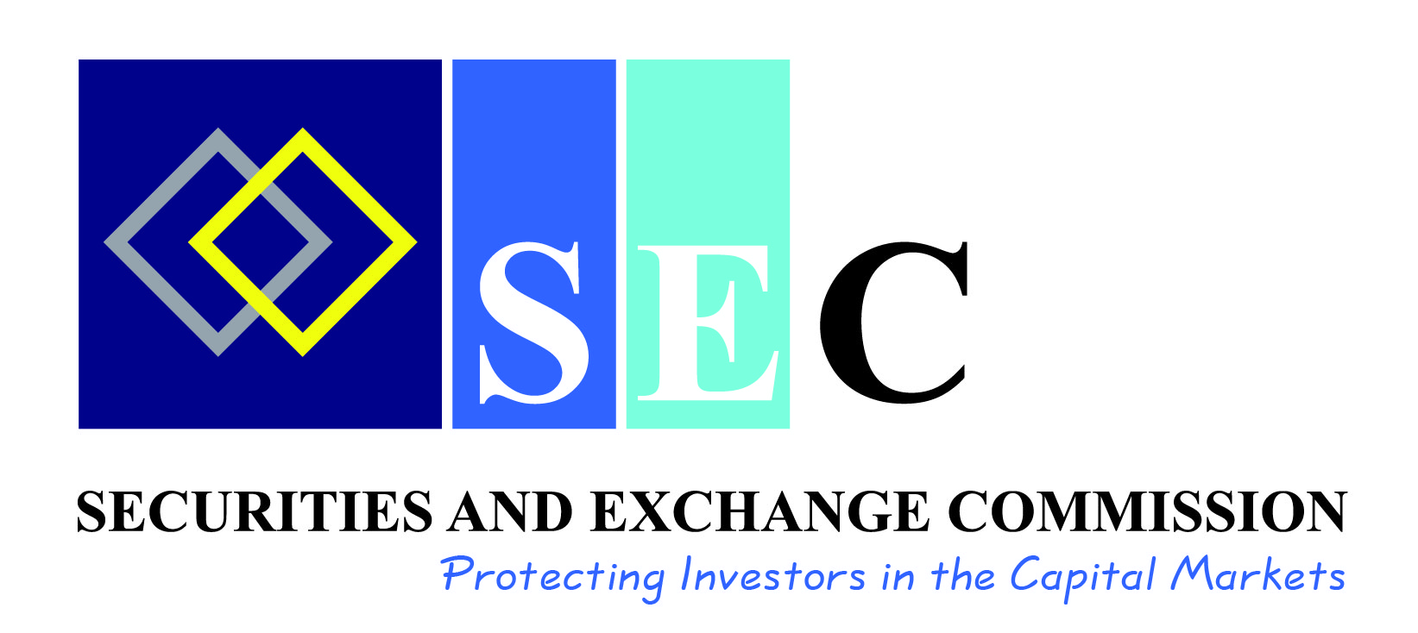

**“SCAM” ALERT: VELMONT GOLD MINING COMPANY**

The Securities and Exchange Commission ("the Commission") has identified a purported investment scheme operating under the name **“Velmont Gold Mining company” (Velmont).** The scheme is actively promoted on social media platforms like Facebook and WhatsApp, inviting the public to invest K128 for 40-days, with a promise of earning K6.40 daily and a total pay-out of K256 at maturity, representing a 100% guaranteed return.

The Commission wishes to advise the public that Valmont, its promoters and/or representatives are **NOT** licensed or authorized or registered by the Commission to provide such investment services or to solicit for funds from the Zambian public for investment purposes.

The Commission therefore advises the public to be cautious and report all matters of fraud to the Zambia Police for their further action.

Investors are advised to be smart and do the following to reduce investment fraud and other risks:

* **Ask Questions:** Fraudsters are counting on you not asking questions. Do your own due diligence by doing independent research on the investment scheme or products being offered to you. Take time to understand how the investment generates income, ask specifically what product or service is creating the returns being promised. Do not be in a hurry to invest.
* **Verify that the intermediary,** **i.e., the Dealer (broker or fund manager) and/or Investment Adviser or the person selling you the product is SEC-licensed:** It does not matter whether you know the person socially. As an investor, it is important to deal with a SEC licensed Investment Adviser or firm. SEC licensees are required to follow supervisory rules and regulations that are put in place to safeguard an investor by mitigating risk exposures to investments. Do not shy away from demanding to see a requisite SEC licence.
* **Conduct research on a product before you invest:** this enables you to assess the level of risk associated with the investment and the expected return thereby guiding you in selecting the most favourable investment. Unsolicited emails, messages and all manner of adverts should not be the sole basis for your investment decisions. Understand a company’s business and its products or services before investing. If need be, consult a duly SEC licensed broker/Dealer and/or investment adviser. Do not fail to ask the right questions.

Issued by the Securities and Exchange Commission.

19th September 2025.