A SMART INVESTOR’S JOURNEY
MASTER YOUR
MONEY


LAUGH AND LEARN HOW TO PROTECT YOUR FINANCES


Your Shield Against
Financial Fraud
Knowledge is your best defense. The Video below reveals how smart investors spot lies, ask the right questions and sleep soundly.
Get the full toolkit. Watch Video!
WHY YOUR MONEY CHOICES MATTER

Ever wondered why some purchases make you richer while others drain your wallet?

Discover the core principle of investing and laugh along the way! Dive into our first video to reshape your financial mindset.
Ready to laugh and learn? Watch Video.



Exciting investment offers can hide dangerous scams. In the video below, see how a simple SMS almost tricks a hopeful investor and learn to protect yourself.
Be a Smart Investor
Avoid Scams
Don’t risk your savings!
watch video now
Too Good To Be True
It Probably Is.

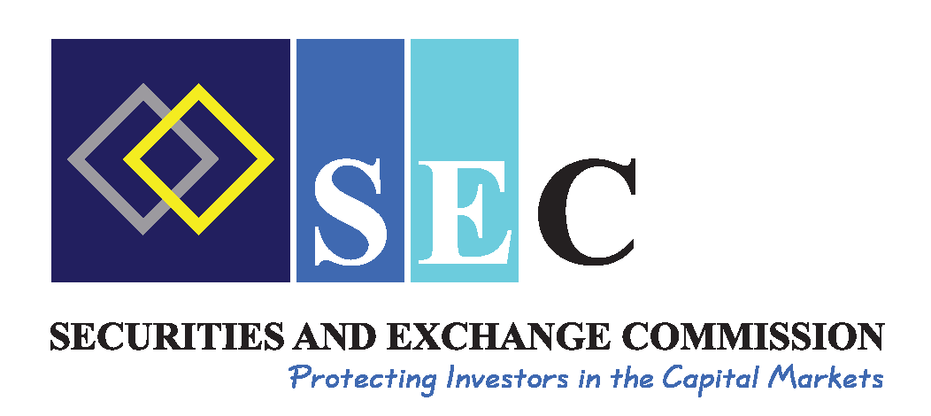
Brought to you by Investor Education Fund, the financial sector joint messaging communication, a partnership from the Central Bank of Zamba, Pensions and Insurance Association, The Securities and Exchange Commission.
SHARE THESE VIDEOS!
PROTECT YOUR COMMUNITY.
- INVEST IN GROWTH (NOT LIABILITIES)
- VERIFY EVERY OFFER (IGNORE “GET RICH QUICK” SCHEMES)
- TRUST ONLY LICENSED EXPERTS (CHECK SEC ZAMBIA’S DATABASE)
YOU’RE NOW SMARTER THAN MOST INVESTORS

